A

Project Report On

**“PERSON FINDER”**



**Prepared by**

18DCS003 | JIMMY AGHERA

18DCS007 | RUDRA BARAD

18DCS013 | HARDIK CHAVDA

**Under the Supervision of**

Assistant Prof. Krishna Patel

**A Report Submitted to**

Devang Patel Institute of Advance Technology and Research

Charotar University of Science And Technology (CHARUSAT)

Bachelor of Technology (B.Tech) in

Computer Science & Engineering (CSE)

for Partial Fulfillment of the Requirements for the

6th Semester Software Group Project-IV(CS349)





**Charotar University Of Science And Technology**

**At: Changa, Dist: Anand – 388421**

**April, 2021**



**CERTIFICATE**

This is to certify that the report entitled “**Person Finder**” is a bonafide work carried out by **Mr. RUDRA BARAD | 18DCS007** under the guidance and supervision of **Assistant Prof. KRISHNA PATEL** for the subject **CS349** | **Software Group Project-IV** (CSE) of 6th Semester of Bachelor of Technology in **DEPSTAR-CSE** at Faculty of Technology & Engineering- CHARUSAT, Gujarat.

To the best of my knowledge and belief, this work embodies the work of candidate himself, has duly been completed, and fulfills the requirement of the ordinance relating to the B.Tech. Degree of the University and is up to the standard in respect of content, presentation and language for being referred to the examiner.

|  |
| --- |
| Ms. Krishna Patel  (Asst. Professor cum Research Fellow)  Department of Computer Science & Engineering  DEPSTAR, CHARUSAT, Changa, Gujarat |
| Dr. Amit Ganatra  Principal, DEPSTAR  Dean, FTE  CHARUSAT, Changa, Gujarat.  Prof. Parth Goel  I/C Head of Department  Department of Computer Science & Engineering DEPSTAR, CHARUSAT, Changa, Gujarat | |

**ABSTRACT**

Technology today has changed our outlook the way we experience this real world. In couple of years’ technologies has changed how we do small and large number of things. Technology came out with new advance level where user can virtually visualize the object in the real world. Machine Learning is here with many solutions and offers user engagement to its extreme level.

For example, on estimation 8 million people are said to go missing each year, worldwide out of which only 1.3 were reported. According to the surveys conducted by multiple organizations in India approximately 60,000 children are going missing every year.

Considering this current scenario, we thought of creating a web application that can benefit the ones who goes missing every now and then.

According to the recent reports, Machine Learning is going to be a trillion-dollar industry by 2025. So, keeping both the points in mind we decided why not create a Machine Learning Web Application through which one can easily register or find a person or their loved ones who went missing. Instead of going every place, asking each and everyone about them, showing their photos, or filing an FIR which we all know that, it is just a piece of paper that most of the police stations don’t pay attention to.

In that scenario, our web application Person Finder can easily spread throughout the country or continents just by a single click of button. If your loved one is found by a person then they can easily upload his/her photo and can contact you instantly.

**ACKNOWLEDGEMENT**

I, the developer of the project “Person Finder”, with immense pleasure and commitment would like to present the project assignment. The development of this project has given me wide opportunity to think, implement and interact with various aspects of management skills as well as the new emerging technologies.

Every work that one completes successfully stands on the constant encouragement, good will and support of the people around. I hereby avail this opportunity to express my gratitude to number of people who extended their valuable time, full support and cooperation in developing the project.

I express deep sense of gratitude towards our Head of the CSE Department, Prof. Parth Goel and project guide Prof. Krishna Patel for the support during the whole session of study and development. It is because of them, that I was prompted to do hard work, adopting new technologies.

I would also like to thank all the mentor for their guidelines throughout the development phase of the project. They encouraged me to look forward to learn and implement new and emerging technologies. They also guided me to go for some user friendly and extremely useful real-life application.

They altogether provided me favorable environment, and without them it would not have been possible to achieve my goal.

**INDEX**

|  |  |  |
| --- | --- | --- |
|  | **Certificate**  **Abstract** | **2**  **3** |
|  | **Acknowledgement**  **Table of Contents** | **4**  **5** |
| **1.** | PROJECT DEFINITION | **7** |
| **2.** | PROJECT DESCRIPTION | **8** |
| **3.** | SOFTWARE & HARDWARE ENVIRONMENT | **11** |
| **4.** | MAJOR FUNCTIONALITTY | **13** |
| **5.** | SYSTEM FLOW CHART | **20** |
| **6.** | SNAPSHOTS OF PROJECT OUTPUT | **22** |
| **7.** | LIMITATIONS OF THE PROJECT | **29** |
| **8.** | PROJECT OUTCOME | **31** |
| **9.**  **10.** | FUTURE ENHANCEMENTS  REFERENCES | **33**  **35** |

**LIST OF FIGURES**

**Fig 1** Login Page **14**

**Fig 2** Home Page **15**

**Fig 3** Register Page  **16**

**Fig 4** Find Page **17**

**Fig 5** Contact Us Page **18**

**Fig 6** Logged Out Page **19**

**Fig 7** System Flowchart **21**

**Fig 8** Authentication Page **23**

**Fig 9** Welcome Page **24**

**Fig 10** Email Validation **25**

**Fig 11** Phone Number Validation **25**

**Fig 12** No Face – Registering **26**

**Fig 13** Proper Validation **26**

**Fig 14** Successfully Added **26**

**Fig 15** No Face – Finding **27**

**Fig 16** No Match Found **27**

**Fig 17** Match Found **28**

**CHAPTER 1: PROJECT DEFINITION**

**To create web application which helps in finding and registering lost people**

**CHAPTER 2:**

**PROJECT DESCRIPTION**

**2.1 PROJECT OVERVIEW:**

Person Finder is a Web Application built with integrating Machine Learning models to recognise and compare multiple faces at a time and helping out the user to find or register their loved ones with ease.

Basically, there are 2 section in our project.

1. **Upload Lost Person**

This section is for the user who hast lost someone in the and wants to find them as soon as possible. For this they’ll need to upload a clear photo of the lost person along with the contact details so that if someone founds him/her then they can contact the user easily.

1. **Find Lost Person**

This section is for the user who have noticed or found that a particular person nearby them is lost. In this scenario, they can pull up our application and upload a clear picture of the lost person, after which our machine learning models will compare lost person’s photo with all the lost persons in database and if match found then the details of the person who uploaded the photo of the lost person will be shown.

**2.2 INTRODUCTION TO DOMAINS:**

**MACHINE LEARNING**

In this post we’ll provide a general introduction to machine learning, which tries to highlight the underlying technical challenges and where we have solutions. Machine learning is the principle technology underpinning the recent advances in artificial intelligence.

Machine learning is perhaps the principal technology behind two emerging domains: data science and artificial intelligence. The rise of machine learning is coming about through the availability of data and computation, but machine learning methodologies are fundamentally dependent on models.

**Data + Model → Prediction**

The emergence of machine learning is closely tied to the emergence of widely available data. [1]

**COMPUTER VISION**

Computer vision is the field of computer science that focuses on replicating parts of the complexity of the human vision system and enabling computers to identify and process objects in images and videos in the same way that humans do. Until recently, computer vision only worked in limited capacity.

Thanks to advances in artificial intelligence and innovations in [deep learning and neural networks](https://bdtechtalks.com/2017/08/28/artificial-intelligence-machine-learning-deep-learning/), the field has been able to take great leaps in recent years and has been able to surpass humans in some tasks related to detecting and labelling objects.

**WEB APPLICATION**

A web application is application software that runs on a web server, unlike computer-based software programs that are run locally on the operating system of the device. Web applications are accessed by the user through a web browser with an active network connection.

**CHAPTER 3:**

**SOFTWARE AND HARDWARE ENVIRONMENT**

**3.1 HARDWARE AND SOFTWARE THAT WERE USED IN THIS PROJECT :-**

**SOFTWARE USED:**

* VSCode
* SQLite Browser
* PyCharm
* Git
* Jira Software

**SYSTEM CONFIGURATION ON WHICH THE PROJECT WAS DEVELOPED:**

* Laptop/computer with Core i5 8TH gen. Processor
* 2BG Hard Disk Storage
* 8 GB RAM

**OTHER REQUIREMENTS:**

* Python
* Bootstrap
* Django
* Google OAuth

**CHAPTER 4:**

**MAJOR FUNCTIONALITY**

**4.1 Login Page**

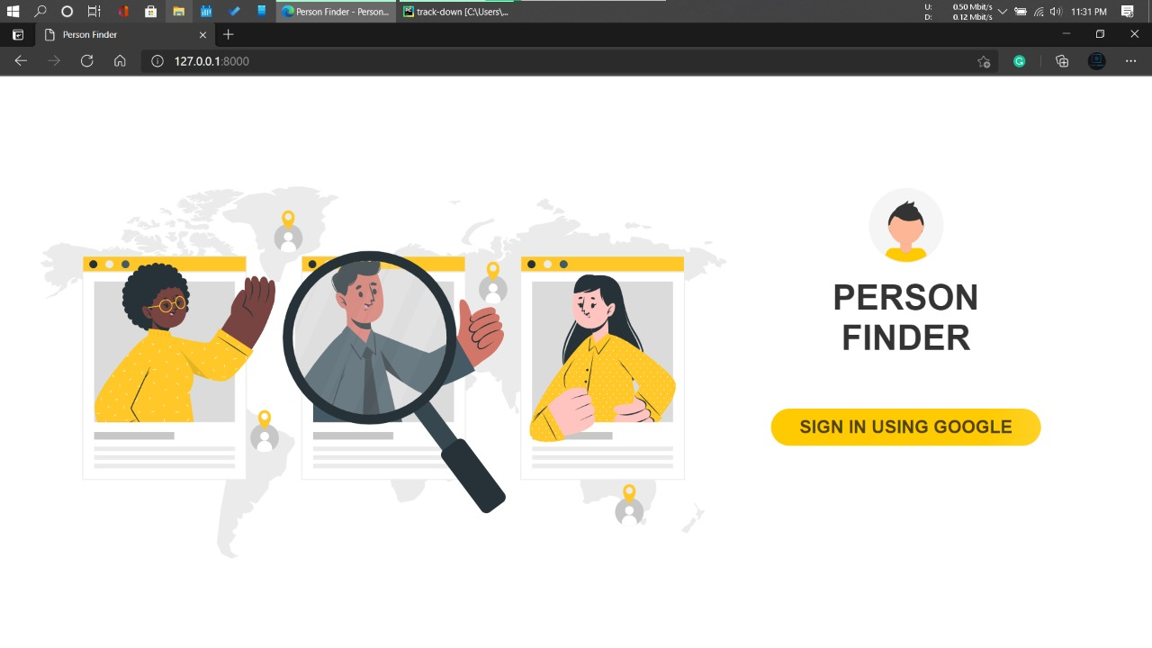

Figure Login Page

On visiting our web application, this is the Login Page that will be seen by the user which consists of Brand Logo and Brand Name of the Application along with the **Login Section.**

For maintaining the security of database and proper authentication we have used Google OAuth authentication so the users need to enter the application by login in with their Google Account. This will also reduce the possibilities of fake accounts since it will be crucial to the database. [3][7]

**4.2 Home Page**

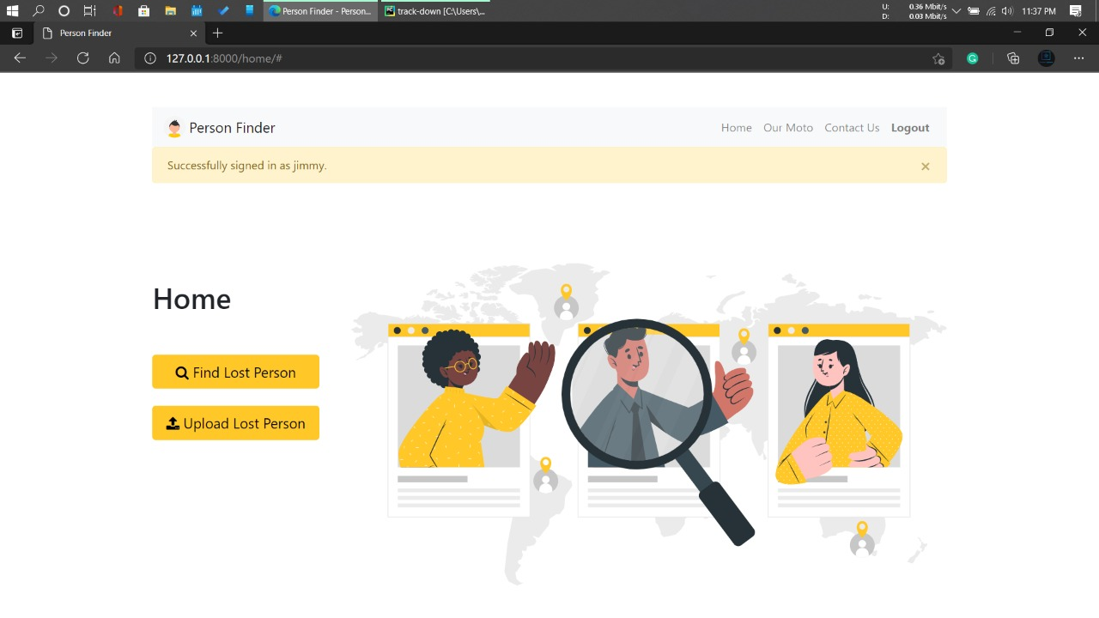

Figure 2 Home Page

After the successful login of the user, he/she will be directed to the **Home Page** where an alert message will be shown saying that the user is “Successfully signed in as <firstname>” and this firstname of the user will be directly fetched from Google Account by our application.

This page consists of the Navigation Bar through which user can redirect to any section with ease. Different sections available for user in our navigation bar are as follows:

1. Home
2. Our Moto
3. Contact Us
4. Logout

Other than that, this page will also show the Buttons for the 2 main purpose of this application which are:

1. **Register** Lost User
2. **Find** Lost User
   1. **Upload Page**

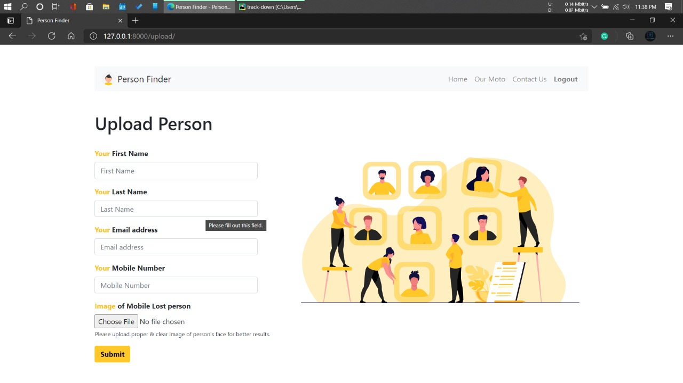

Figure 3 Register Page

This page consists of the **Register** Section for uploading or registering the lost person. If someone found the lost person then one needs to fill the form which includes the following details:

1. First Name
2. Last Name
3. Email Address
4. Phone Number
5. Photo of the Lost Person
   1. **Find Page**

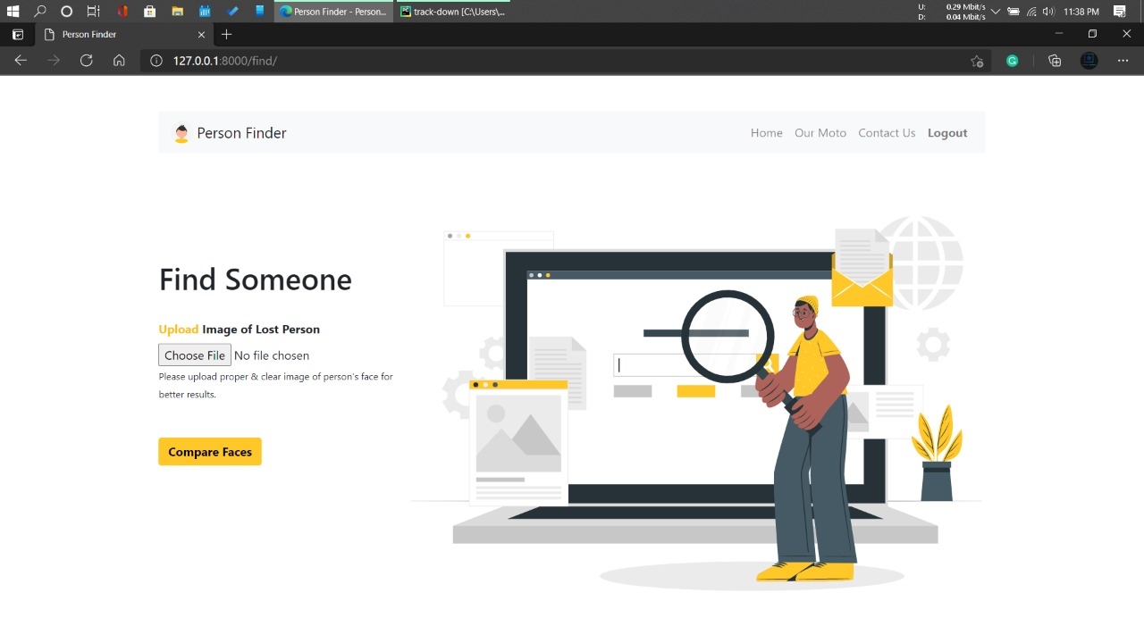

Figure 4 Find Page

This page consists of the **Find** Section for finding the lost person. If user’s loved ones or relative went missing then the user need to upload the clear photo of the lost person to find whether anyone around the world have found the lost person and uploaded/registered on the application.

* 1. **Contact Us Page**

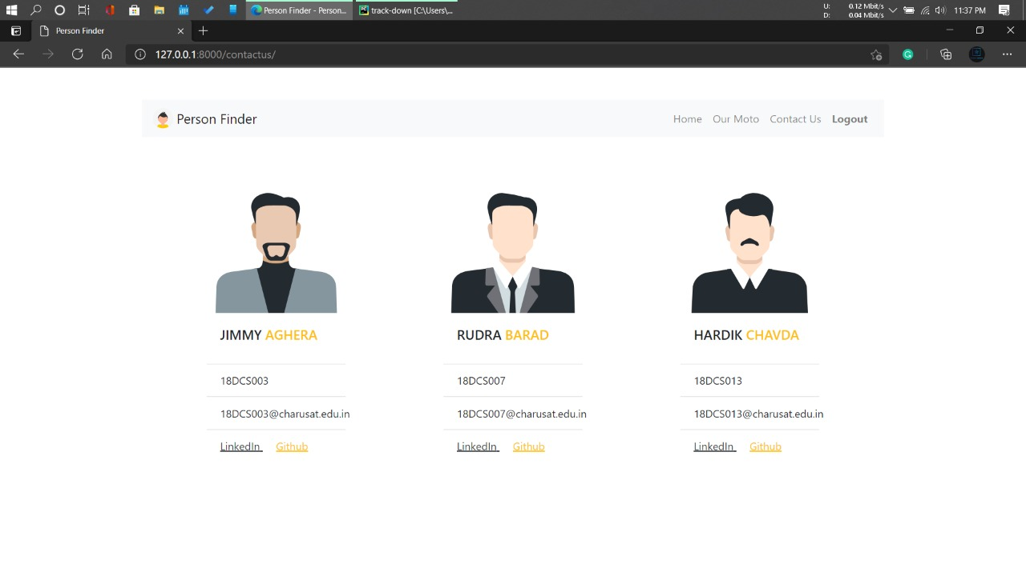

Figure 5 Contact Us Page

On click the **Contact Us** button on the navigation bar the user will be directed to this page where there are details of the developers/owners of the application.

For any kind of queries or help they can easily contact them with their links given to their professional social accounts.

* 1. **Logged Out Page**

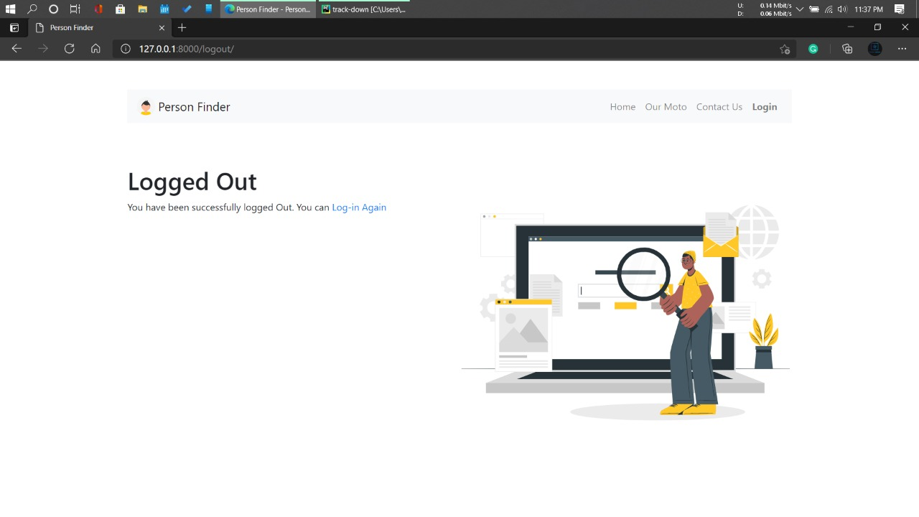

Figure 6 Logged Out Page

On clicking the **Logout** Button from the Navigation Bar, the user will be logged out of his/her account and will be redirected to this page.

For using any of the section or the part of the application again, user will again need to login which he/she can login from the links available on this page and if not then they can just close the application.

**CHAPTER 5:**

**SYSTEM FLOWCHART**

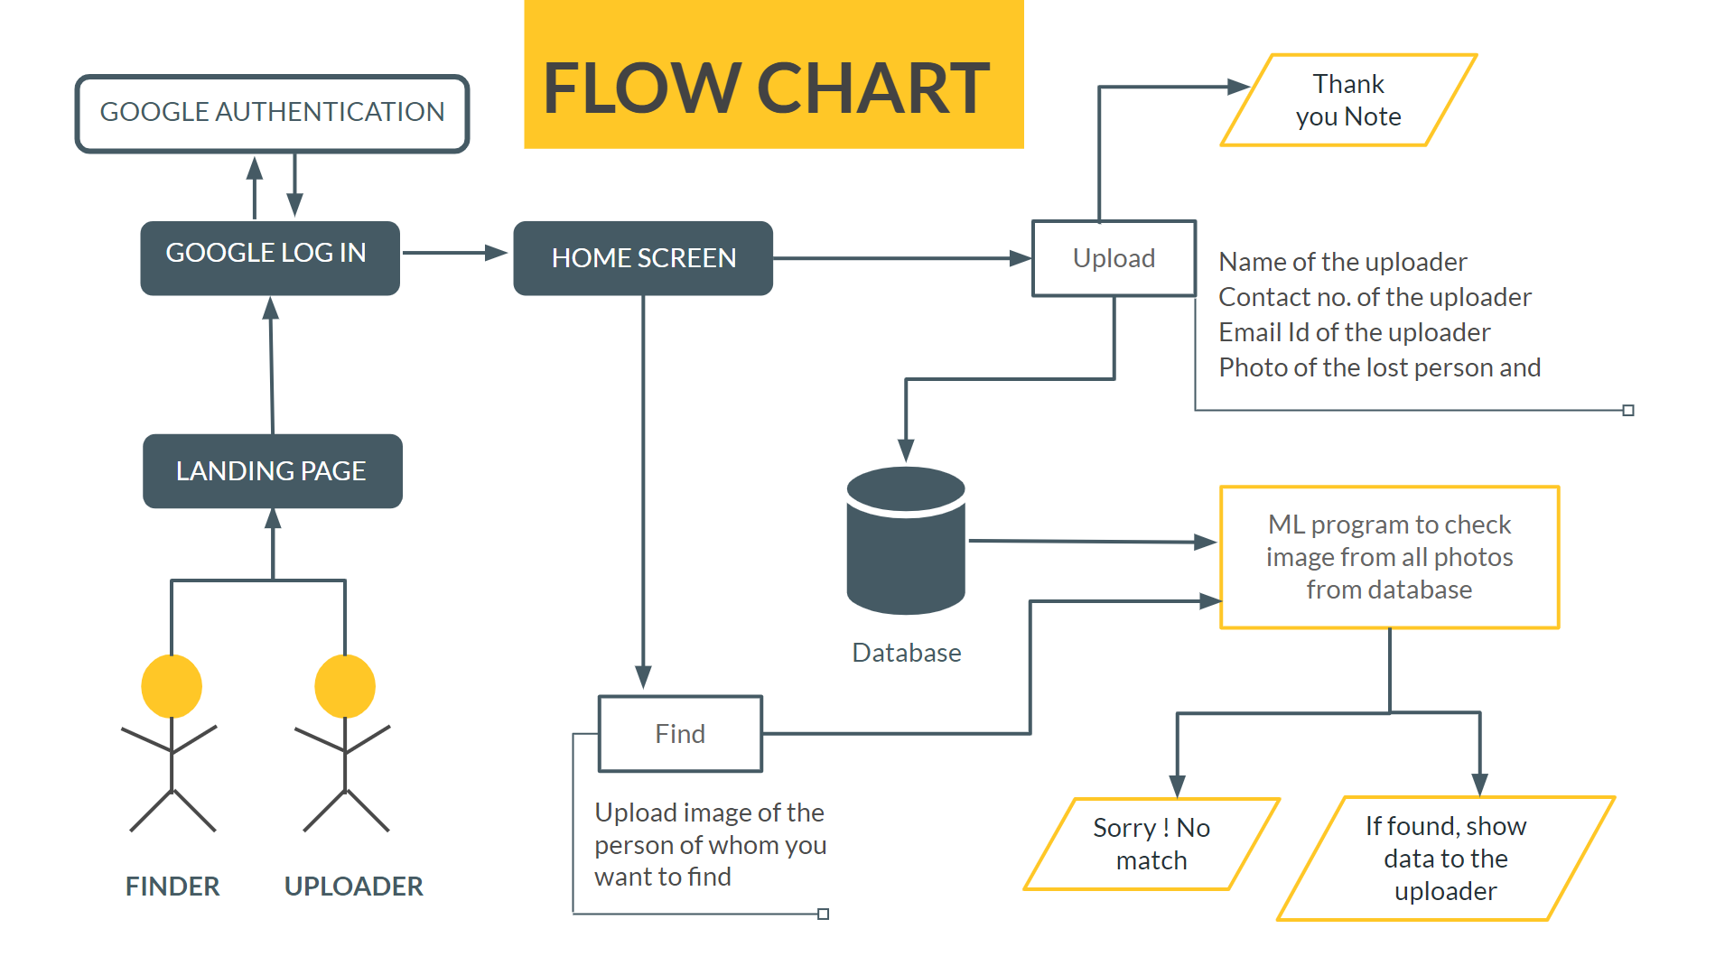

Figure 7 System Flowchart

**CHAPTER 6:**

**IMPLEMENTATION SNAPSHOTS**

**OF PROJECT**

Google Authentication Required for logging in to the application. [5][6][10]

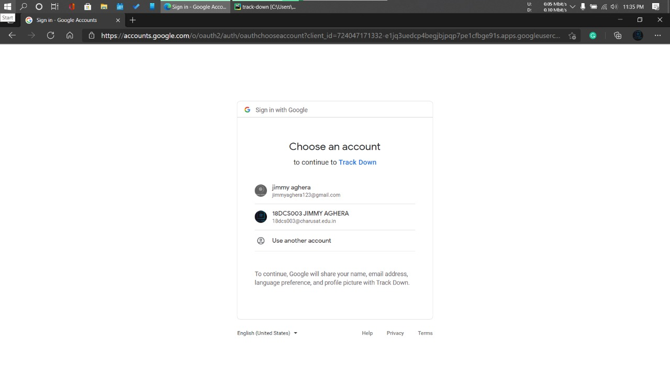

Figure 8 Authentication Page

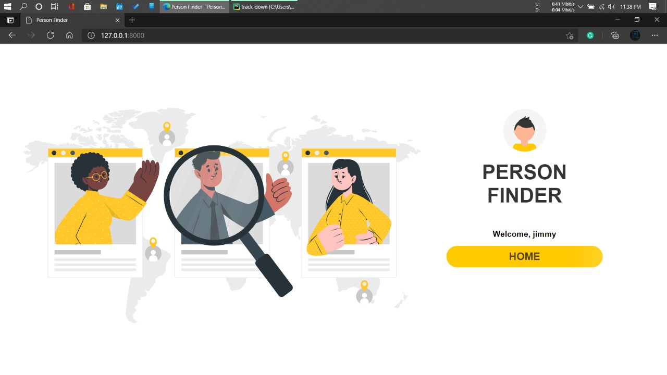

Figure 9 Welcome Page

After the successful login of the user, the user will be directed to the page with Home Button and after clicking that, Home Page will be shown.



Figure 2 Home Page

While filing the details, user needs to input the valid user email id and valid phone number in order to register a lost person.

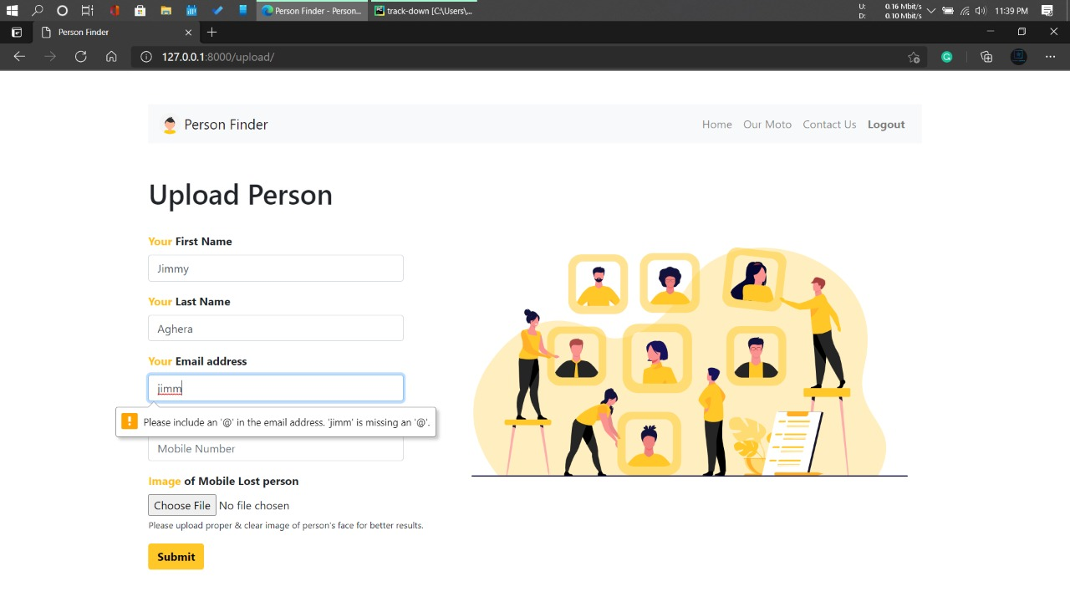

Figure 10 Email Validation



Figure 11 Phone Number Validation

If a person selects and uploads the image in which there is no face then the application will ask the user to again upload a photo of the lost person where a face can be found.

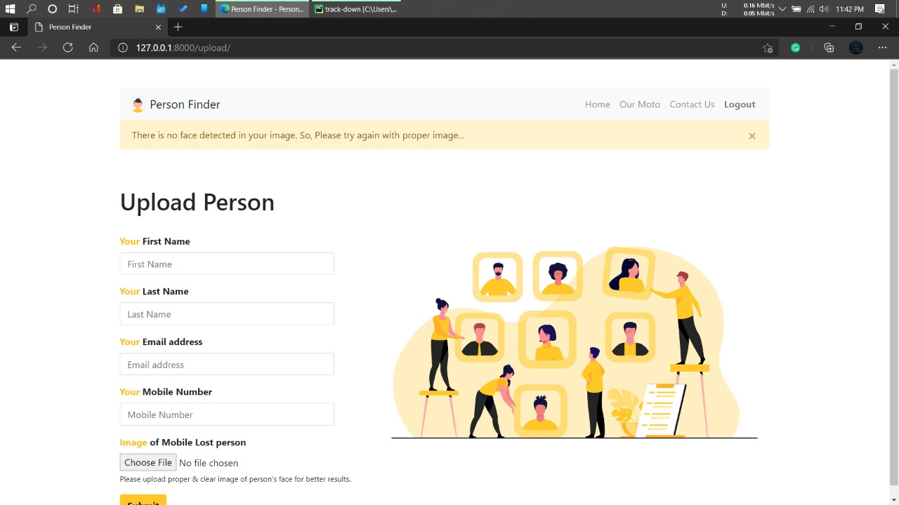

Figure 12 No Face - Registering

If user inputs every details properly with all the validations as shown below then he/she will be directed to home page, with message showing that “Thank you for adding”.

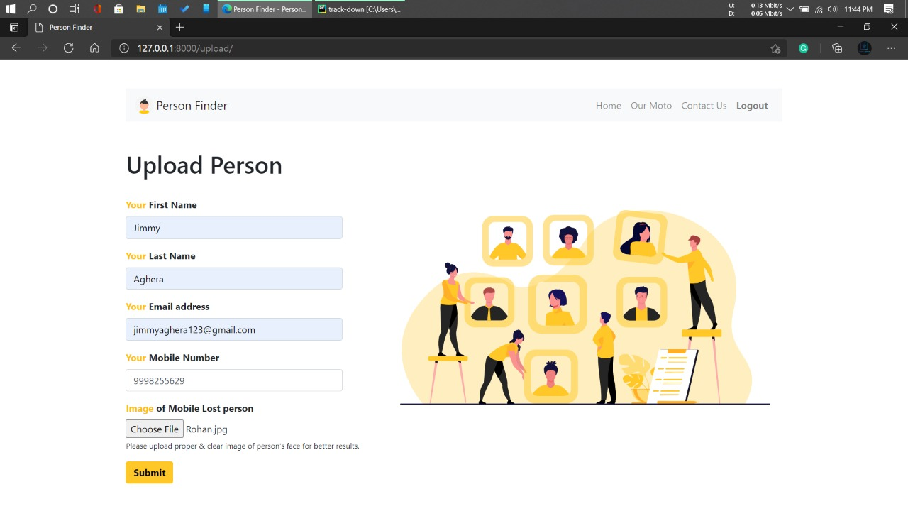

Figure 13 Proper Validation

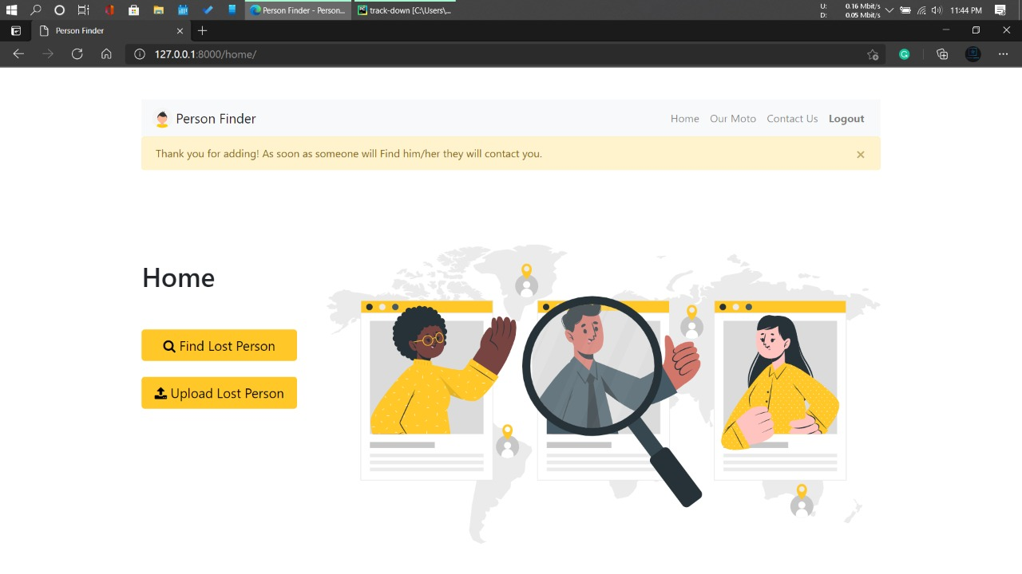

Figure 14 Successfully Added

While finding the lost person if the user inputs the photo with no face, then below message will be shown.

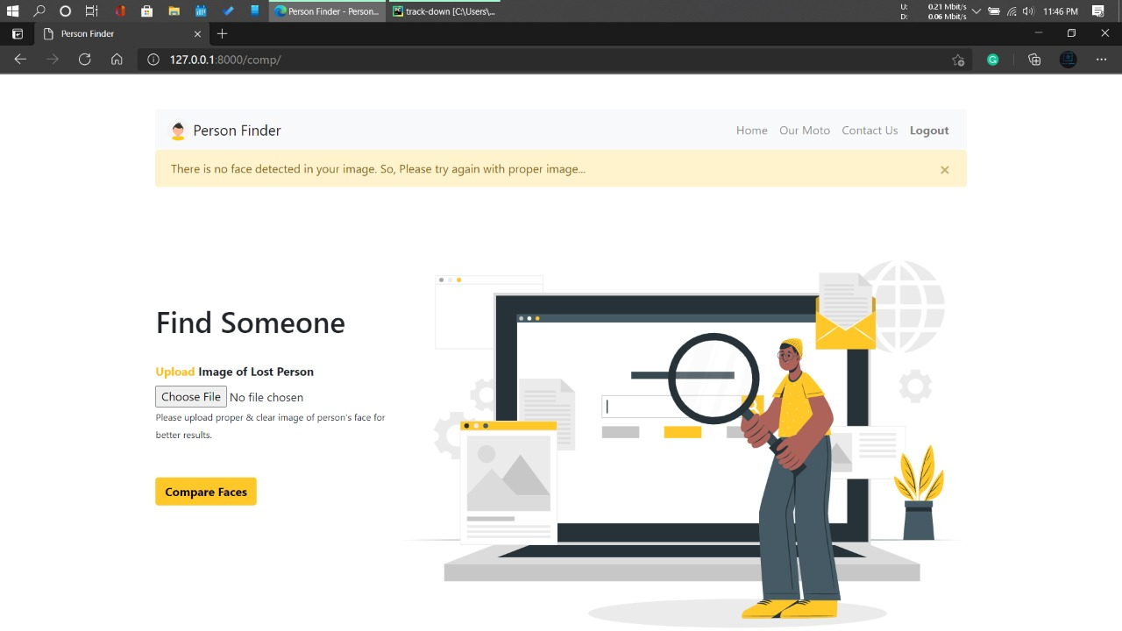

Figure 15 No Face - Finding

While finding the lost person if user inputs the photo of lost person having a proper face but if the lost person is not in the database or not registered with the application then it will show “No Match found” and will ask user if he/she wants to register the lost person.

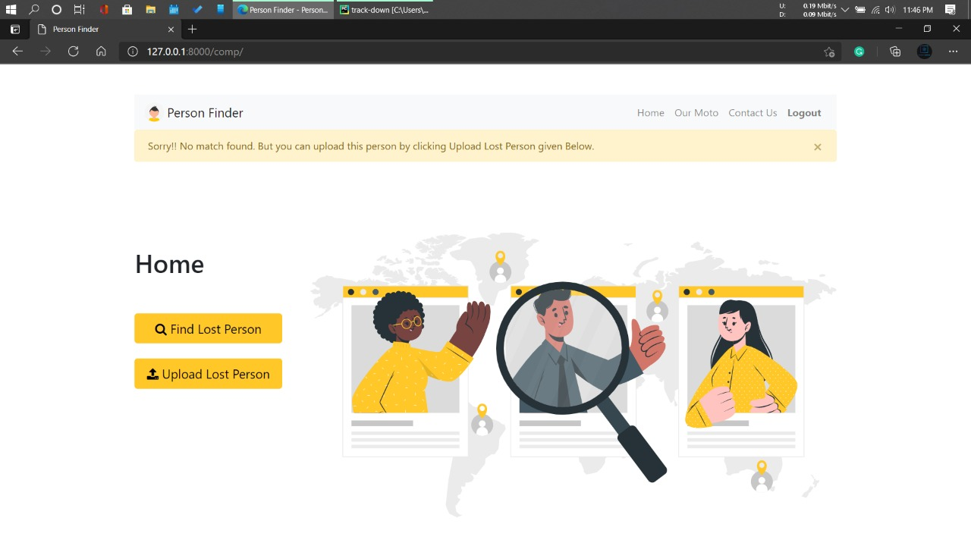

Figure 16 No Match Found

While finding the lost person, after uploading a proper image of the lost person, if application founds that the same person is registered with the application and some user have uploaded the photo of the lost person then application will show the following details of the uploader to the person finding the lost person: [1]

1. First Name
2. Last Name
3. Email Id
4. Image of the Lost Person uploaded by someone
5. Image uploaded by the person finding the lost person

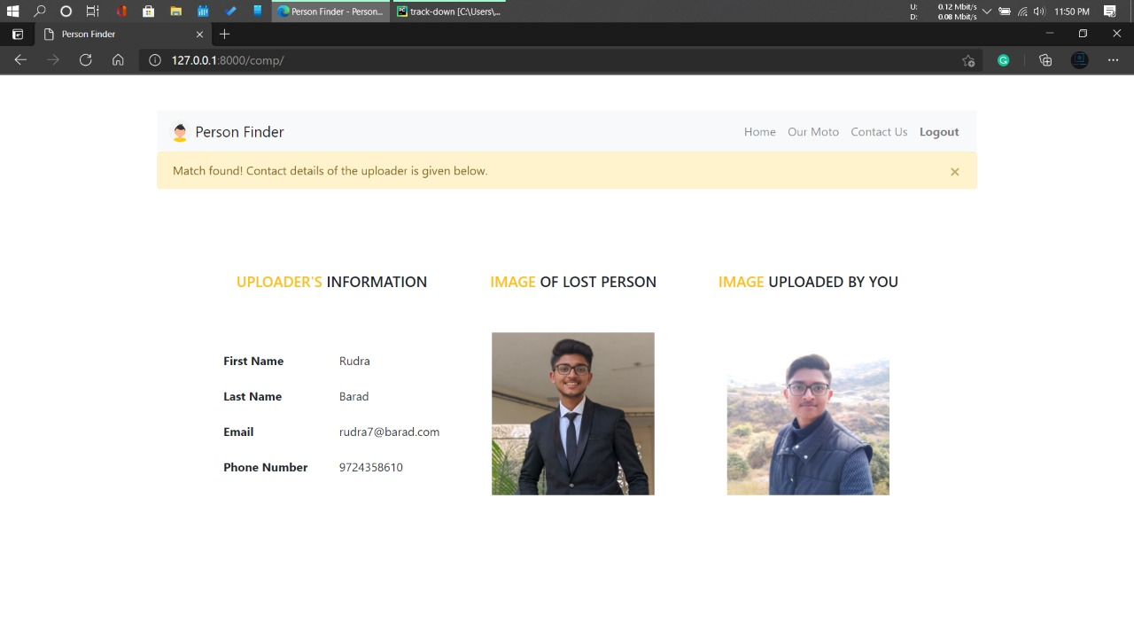

Figure 17 Match Found

**CHAPTER 7:**

**PROJECT LIMITATIONS**

**Responsive website**

The website is not responsive up to the mark. Since an ideal application is one which works efficiently and looks good on web as well as mobile phones.

**Loading**

As someone uploads the image, regardless of register or find, each and every time it will encode it. So, it takes time to encode and then compare with other images and then make an array of output with each and every image. And then and only then it will show output based on that. So, it does encoding of every image every time, due to which it will take time to process it.

**Make it Global**

Data is setup is done with Indian perspective.

**Limited Filters**

More Filters Could be added to get accurate results about the lost person. [4]

**CHAPTER 8:**

**PROJECT OUTCOMES**

We successfully implemented the Google OAuth to allow the user to login in the application. This makes the login process faster and easier. Also reduces the risk of fake users.

There are 2 main options for the user, which are to **Register** and to **Find** a lost person.

For registering the user needs to input the details of him/her along with the image of the lost person. While finding a lost person, application takes an image from the user and tries to match it with the existing images of lost people present in the database. As soon as it founds a match it shows the image of person user uploaded and the one it matches with side by side so you can verify if the person is same or not.

This will save a whole lot of time of the user. Instead of worrying and being emotionally weak, user can think practically and pragmatic when someone near or dear one is lost. [8]

**CHAPTER 9:**

**FUTURE ENHANCEMENTS**

**Notification**

When a person is found then the uploader gets notified automatically

**Instant Search**

Connecting it with CCTV Cameras in order to find anyone at any instant

**Expanding**

Expanding the database and reachability of people around the world

**Time Complexity**

Time complexity of searching can be reduced by using clustering.

**Custom User Accounts**

Making custom user account for the application, to keep track of the user’s activity.

**CHAPTER 10:**

**REFERENCES**

1. [face_recognition/examples at master · ageitgey/face_recognition (github.com)](https://github.com/ageitgey/face_recognition/tree/master/examples)
2. <https://creately.com/>
3. <https://material-ui.com/getting-started/templates/>
4. <https://trackimo.com/facts-statistics-on-missing-persons/>
5. <https://www.youtube.com/watch?v=56w8p0goIfs>
6. <https://www.section.io/engineering-education/django-google-oauth/>
7. <https://www.geeksforgeeks.org/django-authentication-project-with-firebase/>
8. https://www.youtube.com/watch?v=Y4c4ickks2A
9. <https://whizzoe.medium.com/in-5-mins-set-up-google-login-to-sign-up-users-on-django-e71d5c38f5d5>
10. https://adiyatmubarak.wordpress.com/2016/10/26/save-media-files-to-local-disk-on-django-storages/